University of Virginia Center for Politics
Redistricting: The Case of the Curious Gerrymander- PartII
Pushpin Redistricting Game

Purpose: A continuation of The Case of the Curious Gerrymander Part I, this interactive simulation helps to provide students with a working knowledge of how Congressional voting districts are established, as well as the opportunities for partisan redistricting in the determination of these districts. By learning an alternative method to this, students may realize the democratic merits of bipartisanship.

Objectives:
- Students will be able to define partisan redistricting in order to learn how partisan redistricting affects voter representation and participation.
- Students will experiment with various redistricting options in order to determine which strategy would best meet the needs of their state.
- Students will evaluate the status of voting districts within their states in order to support redistricting reform or to remain with the current strategy for redistricting.

Key Words
congressional district partisan packing
cracking gerrymandering bipartisan redistricting

Materials
- Teacher Resource: 2015 Pushpin Redistricting Game Instructions (provided)
- 2015 Redistricting Game Map (provided)
- Cork Backing cut into pieces of 81/2” X 11” for 2015 Redistricting Game Map (Can be foam core- found at craft stores)
- 2015 Redistricting Game Score sheet (provided)
- Box of Pushpins
- Box of Rubber Bands with at least 5 different colors (Can be colored with markers)

Background for More Info on Gerrymandering:
Washington Post: https://www.washingtonpost.com/news/wonk/wp/2015/03/01/this-is-the-best-explanation-of-gerrymandering-you-will-ever-see/?utm_term=.199c33d41d50
OneVirginia 2021. Gerryrigged: Turning Democracy on its Head-https://www.youtube.com/results?search_query=gerryrigged+turning+democracy+on+its+head
American Law Journal. Gerryrigged: Is Redistricting Killing our Democracy- https://www.youtube.com/watch?v=mOL5YMzfdxc&t=943s
Partisan Redistricting Game Map

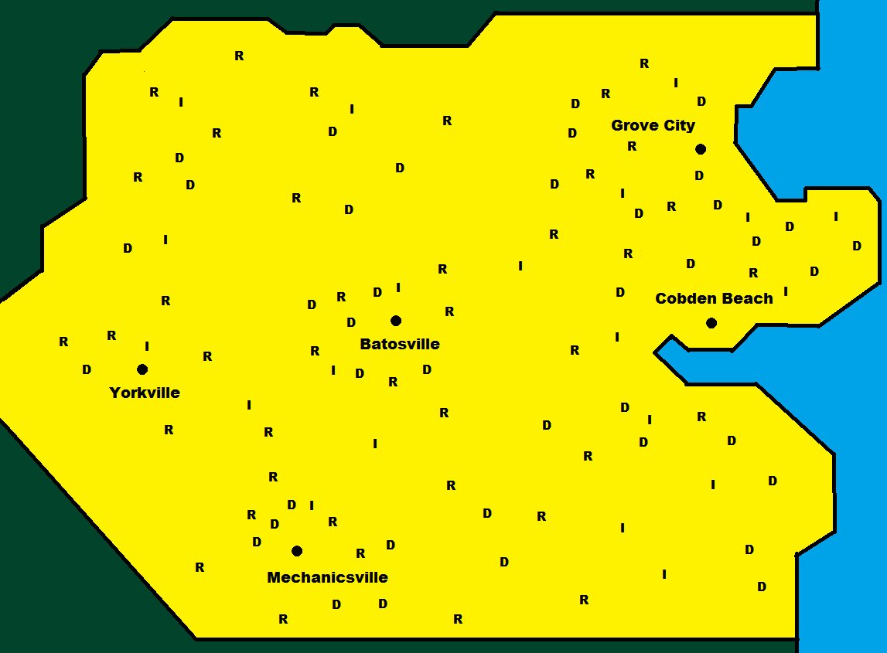
Teacher Resource 2015 Pushpin Redistricting Game Instructions

Initial Outlay: In this game, we provide the students with a map of Franklin, with different letters to represent the relevant voting party. There are 40 Democrats (D), 40 Republicans (R), and 20 Independents (I) in this image. Students are broken up into three or more teams, representing a Republican side, a Democrat side and an Independent side. They are provided with rubber bands, as well as a uniform number of pushpins, which will be used as mounting points for the rubber band districts and inside the districts they will capture the voters.

Round 1: Just as in the game Battleship, where there are ships of varying sizes, in this round the students, as one team, will use a specific number of pins to create different-sized districts, with every voter captured; two 3-pin districts, one four pin districts, one five pin district, one six pin district. Numbers of captured votes are tallied on the scoresheet (provided), and compared in front of the class.

Round 2: A more competitive round, this one pits the three sides against each other to capture the most of their own party, making the opposing party a minority in a packed district. The students will be split between a Democrat side, a Republican side and, if there are enough students, an Independent side per map. There will be five districts created within ten minutes. The teams will take turn creating the district, with the Democratic and Republican team’s each getting to create two and the Independent team getting to only create one. Each district must contain at least one voter from each different party and has to contain 20 voters. If there are only two teams, each team gets to create two districts with the same rules with a final district being made up of all voters that weren’t included in the previous districts. At the end the voters can be counted to see which team won more votes for their party, and tallied on the scoresheet. After this round, inform the students of packing/gerrymandering in general and its harmfulness to democracy and accurate representation.

Round 3: A more cooperative round, the students will try to solve the partisan redistricting problem by having collaboration and equal party representation in each district to within 2 voters or so.
After this round, teach about proposed solutions to the partisan redistricting problem, such as third parties or bipartisan collaboration.

2015 Pushpin Redistricting Game Scoresheet

Round 1
District | Republican Votes | Democrat Votes | Independent Votes
D1
D2
D3
D4
D5
Total:

Round 2
District | Republican Votes | Democrat Votes | Independent Votes
D1
D2
D3
D4
D5
Total:

Round 3
District | Republican Votes | Democrat Votes | Independent Votes
D1
D2
D3
D4
D5
Total:

Optional: Version 2, State of Franklin, w/o Pre-Rendered Voters
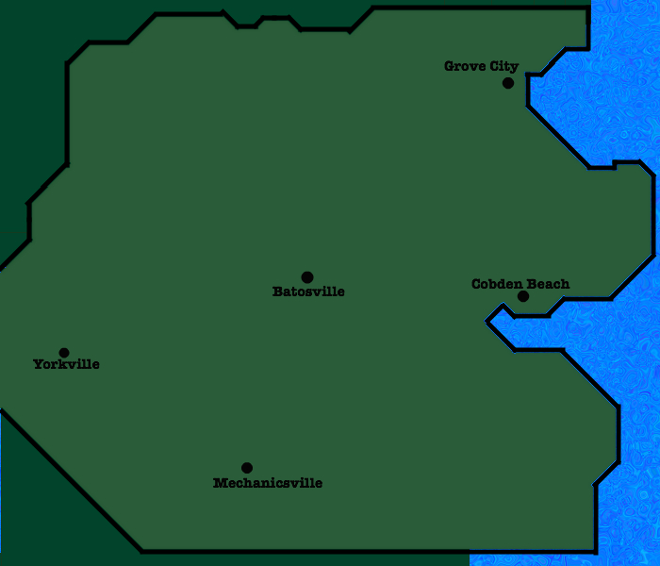
Version 2, Franklin with an Empty Map Upon Which we Use Pushpins to Represent Voters

