The University of Virginia Center for Politics
Redistricting: The Case of the Curious Gerrymander
Part I

Purpose: Do voters pick their elected officials or do the elected officials select their voters? This lesson introduces the concept of re-districting as vaguely defined by the Constitution and asks participants to assess the effectiveness of that definition in light of current Supreme Court cases and evidence from past elections. Students will interpret maps, look at voting data, and experiment with various districting options in order to determine what can be done to increase citizen participation in elections.
Objectives:
Students will determine the meaning of gerrymandering in order to determine the effect that the practice has on the right of citizens to elect their representatives.
Students will examine strategies for making the redistricting process less political in order to determine how the country might solve the problem of gerrymandering.
Students will analyze the work of organizations working to promote redistricting reform in order to suggest strategies for engaging citizens in a democracy.
Vocabulary:
Gerrymandering Packing Cracking Incumbent Census
Materials:
Student resource, The Case of the Curious Gerrymander: Maryland Congressional District 3
Student resource, The Case of the Curious Gerrymander: Drawing Districts
Student resource, The Case of the Curious Gerrymander: CASE SHEET
Illustration, The Case of the Curious Gerrymander:History of Gerrymandering
Article, Justices to Hear Major Challenge to Partisan Gerrymandering
Clue #1, The Constitution (or listen to the Diane Rehm show using the link below)
Clue #2, Redistricting Across the Nation
Clue #3, Political Parties and Re-Districting
Clue #4, How to Use Re-districting to One’s Advantage
Clue #5, Gerryrigged
Clue #6, Background Data on Re-districting
Student resource, Redistricting Resource Guide

Resources:
GerryRIGGED: Turning Democracy on its Head (Documentary)- One Virginia 2021
https://www.youtube.com/watch?v=vD3ZZ-wzrHQ

2017 EMMY NOMINEE: Gerryrigged! Is Re-districting Killing Our Democracy?
Documentary: https://www.youtube.com/watch?v=mOL5YMzfdxc
The Diane Rehm Show: http://dianerehm.org/shows/2011-03-22/constitution-today-redistricting
NOTE: This lesson contains a lot of material. In writing the lesson we thought it best to include ample resources for students with little or no access to internet. This lesson can be used in its entirety or broken into sections. The Case of the Curious Gerrymander Part II is a simulation that can be used independently of Part I. It allows the students to experiment with various re-districting strategies and find out which best meets the needs of the people.
Procedure:
Motivation/Warm Up
For homework the night before ask students to interview several people in their neighborhood/community. Have them ask people what congressional district they are in? Did they vote in the last congressional elections? Why or why not? Then ask if they know their state legislative districts? Ask them if they voted in the last state legislative elections? Why or why not? Students should research their congressional and state legislative voting districts using Project Vote Smart –www.votesmart.org. In class review the findings:
How many people knew both their congressional and state legislative districts? Which did they have the most trouble recalling?
What reasons were given for not voting in congressional/state elections?
Did anyone say that they didn’t vote because most candidates were unopposed?
For those who didn’t know their districts did they comment on why they didn’t know?
Introduce students to this statistic, “In 2016, 34 congressional districts candidates ran unopposed. There were many more state legislative races that were unopposed.”
What effect do unopposed races have on voter participation?
Why do you think these races are unopposed?
Do you think it is a good/bad thing to have offices running unopposed?

How are voting districts determined? Project a local voting district for students to see or project the “Maryland Voting District 3: The Wheel of Death.” Discuss the shape of the district and how it might aid citizens in engaging with legislators or how it might detract.
How are districts determined? Students will read, The Case of the Curious Gerrymander:
Drawing Districts and identify:
What does the Constitution say about how legislators should be determined?
Why do most states leave re-districting to the state legislatures?
What is gerrymandering? How does it affect citizens’ voting options?
Do you thing the Framers of the Constitution would approve of gerrymandering?
Why or Why not?
Introduce the assignment by informing students that they will be working in legal teams to try the Case of the Curious Gerrymander. They will work in groups of 3-4 students to build a case that supports the creation of the school’s congressional voting district. . They will research and examine the evidence in this case and determine whether or not the federal government should act to correct the situation in your congressional district, whether or not the state should individually act to solve gerrymandering issues, or whether we should just continue with the current system that depends on most states using their state legislatures to determine districts. Each group is responsible for turning in a brief that outlines its case.
Distribute each student a copy of the CASE SHEET. This is where they will examine each piece of evidence and rank its importance according to their position on the case. There is a wide variety of evidence for students to examine but students can also use the Resource Sheet at the end of the unit to complete independent research to build their case.
Each brief should:
Explain the process of re-districting as defined Constitutionally and through U.S. history
Describe the position that the group feels best benefits the citizens of that state
Provide evidence from the clues/research to support that position
Cite reason(s) why the other options are not desirable
List the benefits to the citizens of that state by following your advice

Extension Activity: Students can research the actions being taken by citizen groups working for districting reform. They can compare/contrast the actions of each group and how successful each action has been. Students may offer suggestions for increasing citizen knowledge of gerrymandering and its effects on democracy.

The Case of the Curious Gerrymander
Maryland Congressional District 3
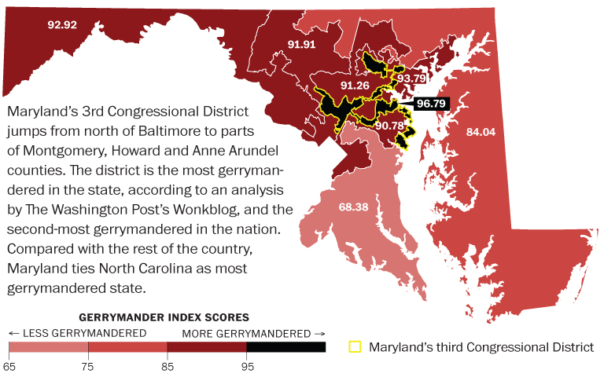

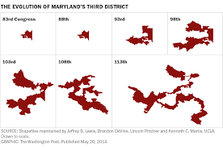
What has happened to Maryland’s District 3 over time?
Why has this district become the “Wheel of Death”?
What impact does the shape of the district have on the ability of legislators to work for their constituents?
The Case of the Curious Gerrymander
Drawing Districts

The act of selecting leaders is vital to a democracy, with elections giving citizens the chance to elect new leaders to represent them and to oust representatives who aren’t meeting their needs. However, in 34 Congressional districts in 2016, voters won’t be making a choice. These 34 districts are held by incumbents who faced no opposition in their party’s primary and no major party competition in the general election. They constitute roughly one in 10 Congressional districts, with incumbents in an additional 88 districts lacking a primary challenger and another incumbents sailing back into office without a major party challenger in the general election. This lack of competition is corrosive to our democracy, with the potential to depress voter turnout and worsen polarization.
Elections Raise Concerns About Fair Representation, by Kelsey Kober
September 23, 2016
Fairvote.org

The quote from Kelsey Kober summarizes one of the major reasons that many Americans believe that voting doesn’t matter. When there is only one candidate in a race for public office voters have little motivation to go to the polls particularly if they belong to the party that has no candidate in the race. How does this happen? Shouldn’t there be at least one candidate from the major political parties in each race?
The situation described above is most often the result of redistricting. The Constitution prescribes the number of delegates each state receives but says very little about how they should be chosen. The only requirement for creating voting districts is that they must be contiguous, compact and conform to existing political boundaries. For more information on districting requirements visit http://redistricting.lls.edu/where-state.php.
According to the 10th Amendment- those powers not specifically reserved for the federal government are left to the states. It has been left to the states to determine the process for selecting representatives to the U.S. House of Delegates. The process used in England,- from which most early states drew their political traditions, was to divide the population into geographic districts with each district electing a representative. Most states allow the state legislatures to determine the voting districts every ten years following the census. This means that the majority party in the state legislature has the power to determine where each district will be.
With current technology it is possible for the political parties to determine where voters live and divide districts to benefit their political parties. Some districts are drawn to disenfranchise the minority party by spreading minority party voters over several districts and thus making it impossible for their candidates to be elected. Other districts pack minority party voters together into one district and limit the amount of influence of the minority party. Some districts are divided by a road, with citizens on each side voting in separate districts. This can cause confusion for voters who often don’t realize their voting district has changed. It can also mean that incumbents usually run unopposed since there is little-or-no way for a challenger to receive enough votes to win. The parties don’t support races where they can’t win making it even harder for citizens to run for office.
The process of creating districts favorable to one party or the other is referred to as gerrymandering. Although probably first used by Patrick Henry to keep James Madison from being elected to office, the name comes from a cartoon of a voting district in Massachusetts. The cartoon was printed in the paper and compared to a salamander. Elbridge Gerry, the Governor of Massachusetts, created the monster-like district to benefit his political party- the Democratic-Republicans. For more information on gerrymandering and how it works today visit: https://www.washingtonpost.com/news/wonk/wp/2015/03/01/this-is-the-best-explanation-of-gerrymandering-you-will-ever-see/?utm_term=.5fa935f06411.
The end result of gerrymandering is that politicians choose their voters instead of the voters choosing their politicians. This leads to antipathy and dissatisfaction with the political system. In many non-presidential elections citizens don’t bother to show up at the polls because most candidates run un-opposed. In 2016, 34 congressional seats were unopposed. That may not seem like a large number but each seat represents over 700,000 people which means that millions of people are being represented by candidates that they had no choice electing. To find out more about the effects of gerrymandering on the legislative process visit: http://www.fairvote.org/noncompetitive_congressional_elections_raise_concerns_about_fair_representation
Why is this case curious? It is curious because the United States was founded by citizens who wanted to restrict power over the individual. The evolution of redistricting and gerrymandering has created a system where the individual citizen’s power is restricted by the political parties. It will be up to you to examine the evidence in this case and determine whether or not the federal government should act to correct the situation in your congressional district, whether or not the state should individually act to solve gerrymandering issues, or whether we should just continue with the current system that depends on most states using their state legislatures to determine districts.

The Case of the Curious Gerrymander
CASE SHEET
Carefully examine each clue and record information that will support your case in court. Questions to consider: What is this document trying to tell me? Does this document support/refute my case? How are voters affected by this document? How strong is the evidence? (on a scale from 1-10)
Clue #1 | Clue #2
Clue #3 | Clue #4
Clue #5 | Clue #6

The Case of the Curious Gerrymander
History of Gerrymandering
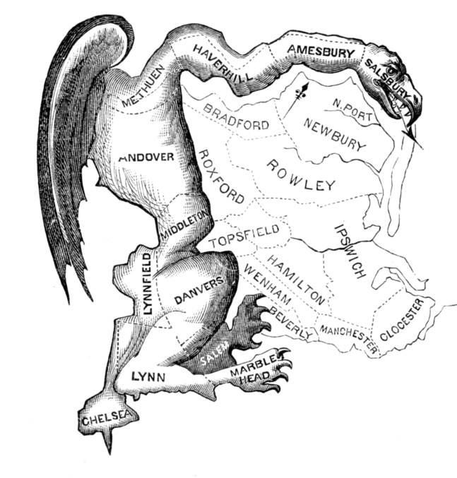
Printed in March 1812, this political cartoon was drawn in reaction to the newly drawn state senate election district of South Essex created by the Massachusetts legislature to favor the Democratic-Republican Party candidates of Governor Elbridge Gerry over the Federalists. The caricature satirizes the bizarre shape of a district in Essex County, Massachusetts, as a dragon-like "monster". Federalist newspaper editors and others at the time likened the district shape to a salamander, and the word gerrymander was a blend of that word and Governor Gerry's last name.
https://en.wikipedia.org/wiki/Gerrymandering

Justices to Hear Major Challenge to Partisan Gerrymandering

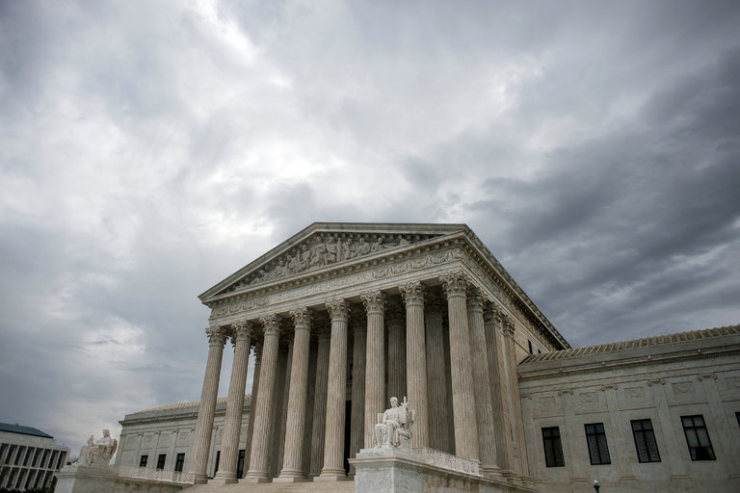
By ADAM LIPTAK JUNE 19, 2017
https://www.nytimes.com/2017/06/19/us/politics/justices-to-hear-major-challenge-to-partisan-gerrymandering.html

WASHINGTON — The Supreme Court announced on Monday that it would consider whether partisan gerrymandering violates the Constitution, potentially setting the stage for a ruling that could for the first time impose limits on a practice that has helped define American politics since the early days of the Republic.
The term gerrymander was coined after Elbridge Gerry, Massachusetts’s governor, signed an 1812 law that included a voting district shaped like a salamander to help the electoral prospects of his party. Over the centuries, lawmakers have become ever more sophisticated in redrawing legislative maps after each decennial census, carving out oddly shaped districts for state legislatures and the House of Representatives that favor their parties’ candidates.
While the Supreme Court has struck down voting districts as racial gerrymanders, it has never disallowed a legislative map because of partisan gerrymandering.
The new case is an appeal of a decision striking down the legislative map for the Wisconsin State Assembly drawn after Republicans gained control of the state’s government in 2010. The decision was the first from a federal court in more than 30 years to reject a voting map as an unconstitutional partisan gerrymander.
The map, Judge Kenneth F. Ripple wrote for the majority of a divided three-judge Federal District Court, “was designed to make it more difficult for Democrats, compared to Republicans, to translate their votes into seats.”

Paul Smith, a lawyer for the voters who challenged the map, said it was time for the Supreme Court to act.
“Partisan gerrymandering of this kind is worse now than at any time in recent memory,” Mr. Smith said. “The Supreme Court has the opportunity to ensure the maps in Wisconsin are drawn fairly, and further, has the opportunity to create ground rules that safeguard every citizen’s right to freely choose their representatives.”
Wisconsin’s attorney general, Brad Schimel, said he was “thrilled the Supreme Court has granted our request” to hear the appeal. “Our redistricting process was entirely lawful and constitutional,” he said.
The case is part of a larger debate over political gerrymandering. Some critics, like Arnold Schwarzenegger, a Republican and the former governor of California,say districts should be drawn by independent commissions rather than politicians. Prominent Democrats, including former President Barack Obama and his attorney general Eric H. Holder Jr., are pushing an effort to undo the redistricting gains Republicans made after the 2010 census when the next census is taken three years from now.
In Wisconsin, the redistricting took place after Republicans had gained complete control of the state government for the first time in more than 40 years. Lawmakers promptly drew a map for the State Assembly that helped Republicans convert very close statewide vote totals into lopsided legislative majorities.
In 2012, Republicans won 48.6 percent of the statewide vote for Assembly candidates but captured 60 of the Assembly’s 99 seats. In 2014, 52 percent of the vote yielded 63 seats.
In the past, some justices have said the court should stay out of such political disputes. Others have said partisan gerrymanders may violate the Constitution.
The fate of the case is very likely to turn on the vote of Justice Anthony M. Kennedy, who has taken a middle position, leaving the door to such challenges open a crack, though he has never voted to sustain one.

Not long after the court agreed to hear the case, it issued an order suggesting the court was quite likely to be closely divided when it hears arguments next fall.
The order granted a request to stay the district court’s decision while the Supreme Court considers the case. The court’s four liberal members — Justices Ruth Bader Ginsburg, Stephen G. Breyer, Sonia Sotomayor and Elena Kagan — dissented. Justice Kennedy was in the majority.
In 2004, Justice Kennedy wrote in a concurring opinion on a gerrymandering case that he might consider a challenge if there were “a workable standard” to decide when such tactics crossed a constitutional line. But he said he had not seen such a standard.
The challengers in the new case, Gill v. Whitford, No. 16-1161, say they have found a way to distinguish the effect of partisanship from the many other factors that influence how districts are drawn.
The proposed standard tries to measure the level of partisanship in legislative maps by counting “wasted votes” that result from the two basic ways of injecting partisan politics into drawing the maps: packing and cracking.
Packing many Democrats into a single district, for instance, wastes every Democratic vote beyond the bare majority needed to elect a Democratic candidate. Cracking, or spreading Democratic voters across districts in which Republicans have small majorities, wastes all of the Democratic votes when the Republican candidates win.
In a recent article, Nicholas O. Stephanopoulos, a law professor at the University of Chicago and a lawyer for the plaintiffs, and Eric McGhee devised a formula to measure partisanship. The difference between the two parties’ wasted votes, divided by the total number of votes cast, yields an efficiency gap, they wrote.
The gap in Wisconsin was 13.3 percent in 2012 and 9.6 percent in 2014, according to the formula. The Wisconsin voters who sued to challenge the Assembly map argued that gaps over 7 percent violated the Constitution. That number was meant to capture the likelihood that the gap would endure over a 10-year election cycle, but critics say it is arbitrary.
Adopting it could transform American elections. A 2015 report from Simon Jackman, then a political scientist at Stanford and an expert witness for the plaintiffs, found that a third of all redistricting plans in 41 states over a 43-year period failed the 7 percent standard. Elections in 2012 and 2014 in Florida, Indiana, Kansas, Michigan, Missouri, North Carolina, New York, Ohio, Rhode Island, Virginia, Wisconsin and Wyoming featured efficiency gaps of more than 10 percent, he found.
Judge Ripple did not ground his opinion in the efficiency gap, relying instead on a more conventional legal test that considered discriminatory intent, the map’s partisan effects and whether they were justified by other reasons. But Judge Ripple did say that the efficiency gap corroborated the majority’s conclusions.
In a supporting brief urging the Supreme Court to reverse the ruling, the Republican National Committee said the efficiency gap “is a tool that advances the partisan interests of the Democratic Party.”
If Democrats lack electoral power, it is because of geography rather than gerrymandering, the brief said. Democrats are often concentrated in cities, effectively diluting their voting power, while Republicans are more evenly distributed across most states, the brief said.
Judge Ripple acknowledged that how voters are distributed explains at least part of the gap. “Wisconsin’s political geography, particularly the high concentration of Democratic voters in urban centers like Milwaukee and Madison, affords the Republican Party a natural, but modest, advantage in the districting process,” Judge Ripple wrote, for instance.
But partisan gerrymandering amplified the Republicans’ advantage, he wrote.
New York Times, June 19, 2017

The Case of the Curious Gerrymander
Clue #1- The Constitution

The U.S. Constitution is vague about how “districts” should be determined. In fact the word district is not mentioned in the Constitution. Why weren’t the Founding Fathers specific in laying out plans for how representatives for Congress would be chosen? In the following interview from 2011 Sean O’brien, Thomas Mann, and Nate Persily, all experts on the Constitution, discuss what the writers of the Constitution may have had in mind in terms of determining voting districts and how that process has evolved over time..
To listen to the interview: http://dianerehm.org/shows/2011-03-22/constitution-today-redistricting
Four states–Virginia, New Jersey, Louisiana and Mississippi – have begun redistricting. It’s a grueling process that’s often politically charged. And the U.S. Constitution doesn’t provide many guidelines. The framers laid out how the number of representatives should be chosen, but left it up to the states to decide how to elect them. In some cases, that’s created vastly unequal and unfair districts, and given rise to cases of Gerrymandering. As part of our “The Constitution Today” series, we examine what the document says about drawing congressional and legislative districts and how court decisions have further shaped those guidelines.

Guests
- Sean O'Brien Executive director, Center for the Constitution at James Madison's Montpelier
- Thomas Mann Senior fellow at the Brookings Institution
- Nate Persily The Beekman Professor of Law and Political Science at Columbia Law School. Founder of drawcongress.org
MS. DIANE REHMThanks for joining, us I'm Diane Rehm. The framers of the U.S. Constitution did not use the word district when they outlined how Congressional representatives would be chosen. Article 1, Section 2 of the document states only how to choose the number of lawmakers. Today, the redistricting process has become at times contentious and blatantly partisan. As part of our "Constitution Today" series, we look at what the document says about the process of redistricting and how court cases have furthered shaped those guidelines.
MS. DIANE REHMJoining me here in the studio Sean O'Brien of the Center for the Constitution at James Madison's Montpelier, Thomas Mann of the Brookings Institution and joining us from Columbia Law School where he is The Beekman Professor of Law and Political Science, is Nate Persily.
REHMSean O'Brien, let me start with you. What does the constitution actually say about legislative districts and I'm glad that you have a copy of the constitution right in front of you, good. Nate Persily has his as well.
O'BRIENAs you indicated in the opening it's very, very vague, as are many things in the constitution, and we have to figure out how to implement what this constitution says. Really what they did initially was set up the initial representation and came up with the number of representatives that each state would have before they knew how many people lived there and set up a minimum number of representatives that each state could have and the maximum size, which they could be.
O'BRIENAnd so they basically -- it just says here the actual enumeration shall be made within three years after the first meeting of the Congress of the United States and within every subsequent term of 10 years, in a manner as they shall by law direct. The number of representatives shall not exceed one for every 30,000, but each state shall have at least one representative. And until such enumeration shall be made and then they lay out which states get how many members of Congress in the first Congress.
O'BRIENAnd that gets into an interesting story that Tom and I were talking about out in the lobby, but again, it's pretty open and that's why we have a lot of opportunities to continue to talk about this issue right now.
REHMAll right. And turning to you, Nate Persily, when did the word district first come into play?
PERSILYWell, for hundreds of years now, we've had districts, but as Sean said, there's no constitutional requirement that we have it. We have since the Supreme Court decisions in the 1960s abided by a rule of population equality for congressional and other districts and are drawn but Congress then has passed statutes, various apportionment statutes over time that have required single member districts and the one that currently exists today is about 90 years old.
REHMNinety years old? Tom Mann.
MANNIt's important to remember the other provision of the constitution that is relevant here is Article 1, Section 4, the times, places and manner of holding elections for senators and representatives shall be prescribed in each state by the legislature thereof. So it was the states that were given the authority to decide how those representatives would be elected. They could have set up a proportional representation system, everyone running at large statewide in which case redistricting would never have arisen as a problem.
REHMSo Nate Persily, why did districts come into play to begin with?
PERSILYWe've had districts for some time and obviously, Great Britain had them even before the U.S. was a country, but the origin of districts comes from a basis in territorial representation that, you know, you can see in the constitution with the requirement of the Senate in that each state should have two senators. And so most -- over time, most of the states have had territorial districting.
PERSILYI should say that some of them have also elected at large at different times and the requirement of districts is only a federal statute. Each state can decide for example for its state legislature or for local councils, et cetera, that you don't have districts and you can elect them at large or proportionally.
REHMWhat does the constitution say about a census to determine the number of representatives?
PERSILYWell, that's the section I just read to you. It just says, it's very brief, the actual enumeration shall be made essentially once every 10 years. And some people get very worked up about the words actual enumeration as opposed to using statistical methods to estimate numbers of people in certain more complicated modern populations.
REHMBut isn't that what we're doing now?
PERSILYSo we've finished the census for this 10-year period...
REHMAnd now?
PERSILYAnd now we're using the data that the census bureau has produced to draw districts in the various states.
REHMBut there was great huffing and puffing about exactly whom to count and who not to count.
PERSILYWell, that's right. We have a long-standing tradition of counting population. Not citizens, but population as a whole and there are some politicians now who are challenging that and saying only legal residents and citizens of the United States should be counted. But the underlying dynamic here is the constitution provides that every 10 years, there is a new enumeration of the population and therefore, the allocation of seats in the House of Representatives to all the states and therefore at the very least those either gaining or losing seats have to redraw their maps going back some time to account for an additional seat or a loss of a seat or two.
O'BRIENOr in the case of Virginia, and in many other states, we have no difference in the number of seats that we get but people have moved, so there are fewer people living in the southern part and southwestern part of Virginia and many more living in Northern Virginia and other urban areas and so that changes the shapes of the districts.
REHMBut Nate, how and when did we get to the 435 U.S. representatives?
PERSILYI'm actually going to defer to Tom on that. I think he probably knows the date. I think it's now sometime over the last 100 years...
MANNYeah, I think it was 1911 where we kept increasing the size of the house. We then got to 435 at the beginning part of the last century and stopped adding. We did temporarily add seats for new states coming in, Hawaii and Alaska. But then in the next census, it fell back to 435, so that the size of the constituencies of members is now pushing toward 800,000, where originally it was 30,000.
REHMWell, is it conceivable that with the growing population in this country, Sean, you could end up with more than 435 representatives?
O'BRIENWell, certainly they've set the precedent for going on 100 years now that 435 is the number.
REHMIs it?
O'BRIENAnd by increasing the number of members of Congress, you would decrease the power of any individual member of Congress.
REHMMaybe that's a good thing.
O'BRIENYeah, but how do you effectuate that change. You have to pass a statute. It's kind of like redistricting, you know, the people in charge of the process.
REHMSean, just how contentious was that debate with the framers over representation?
O'BRIENWell, that debate became a little bit contentious at the end. George Washington wanted -- it was one of the very few times that he spoke up during the entire convention about the representation. But what I think is particularly interesting is in the original Bill of Rights that James Madison proposed, the original 12th Amendment was an amendment about the size of Congressional districts and they would have maxed out at 50,000 people if the original Bill of Rights had passed as proposed by James Madison. So the original 10 amendments are the ones we're all used to, but the original First Amendment would have been a different one and the original 12th Amendment would have been a different one.
REHMOkay. So what did those first districts look like?
O'BRIENWell, they -- the first ones, they basically said, Virginia, you get X number of members and it's up to your state legislature to decide how those people get elected.
REHMOkay.
O'BRIENAnd that's where the interesting story comes in. The history of gerrymandering predates the name gerrymandering and goes back to actually before the first Congress even existed. So Patrick Henry was governor of Virginia, he was an anti-Federalist, James Madison was a Federalist. Patrick Henry arranged for James Madison not to get elected to the Senate because at that time, the Senate was chosen by the members of the state legislature. So James Madison was going to have to run for Congress if he wanted to be able to introduce the Bill of Rights.
O'BRIENHe had been then appointed to the last continental Congress so that he had to travel up to New York to be part of that, or Philadelphia, rather, to be part of that Congress so he wouldn't be able to run locally. And so his friends were saying, James you have got to come back and campaign in your district because the district that has been drawn for you, as described by one person as having 1,000 eccentric angles and it was drawn to put him in the same district with James Monroe who was an anti-Federalist at the time.
REHMWow, you know, it all began way back there.
O'BRIENBack to the beginning.
REHMSean O'Brien, he's at James Madison's Montpelier.
REHMHere's an e-mail from William who says, "Has anyone heard the word gerrymandering? I learned in my history classes that this had been outlawed." Nate Persily.
PERSILYWell, not only is it not outlawed, it has a long historical pedigree as Sean was saying before the break. Gerrymandering comes from Elbridge Gerry, the Democratic Republic Governor of Massachusetts in the early 1800s who drew a district that looked like a salamander and so that's how we got the name gerrymandering. Now, we have salamander and other animal-shaped districts around the country for various levels of office. And gerrymandering itself is not outlawed. What is outlawed and what is unconstitutional are mala-portioned districts, which is to say districts that have different numbers of people in them.
PERSILYAnd so since the 1960s, the Supreme Court has shut down the process of drawing districts that had say a 100 times more people than another. And then there are also other legal prohibitions on racial discrimination. But when it comes to partisan greed in the process or incumbent protection, for the most part, the courts are given a green light toward incumbent politicians drawing their own lines.
REHMBut Tom, back in 2003, you had democratic state legislatures in Texas fleeing the state to prevent gerrymandering.
MANNWell, that's a very famous case where Democrats were in control of the process following the 2000 redistricting and Republicans didn't like the map they drew. Tom DeLay, then an important Republican leader in the U.S. House of Representatives, energized an effort for the Republicans to win full control of the state legislature and then put into place a clear partisan gerrymander to sort of pick up seats. They said, well, it was just undoing a Democratic gerrymandering, but this was contested because it was a mid-decade redistricting taken to the Supreme Court.
MANNIn the end, the court said nothing wrong with doing a second redistricting mid-decade, so they threw that out. And they also basically rejected the notion of a partisan gerrymander. They -- the only thing they did is took objection to one minority district and forced a redraw of that map. But basically what we've had now are three cases in which the court has allowed the possibility of the unconstitutionality of partisan gerrymandering, but in fact, cannot imagine a way of actually seeing it and ruling against it.
REHMDid the framers actually envision politics influencing the process of drawing districts, Sean?
O'BRIENI suppose that would depend on which framer you asked. Of course, George Washington was famous for being totally surprised that parties would develop and he couldn't understand how all of these people who worked so hard together to create the United States would then immediately start bickering. And even the members of his cabinet were bickering with one another. But you can quickly look back at James Madison and the Federalist papers and he's talking about factions right then from the very beginning. And he and Thomas Jefferson, you know, found the first political parties and they -- the political parties were firmly entrenched almost immediately.
O'BRIENI mean, certainly by the time John Adams was elected president, we had active political parties and we had gerrymandering before the parties were really even named. You know, they just sort of defaulted to anti-federalists, 'cause who wants to be called the anti-something?
REHMWell, so Nate Persily, today, how important is redistricting?
PERSILYWell, it's often said that democracy is about voters choosing their politicians. But in the redistricting process, it's politicians choosing their voters. And in many ways, those decisions can be more important than elections in some context.
REHMExplain what you mean when you say it's about politicians choosing their voters.
PERSILYIn most states, we have the either incumbent politicians or the incumbent parties drawing the lines for both state legislature and congress. And the process of drawing lines is grouping people together in certain districts. And if you are worried about who might be challenging you or who might replace you, you draw districts favorable to your politicians or to your political party. And that's the way we've done in the United States and it's achieved a sort of elegant state of perfection at this point.
PERSILYI should say, remarking back on the last point, that we in the U.S. are unique in the level of sort of partisan infection of the redistricting process, that there are plenty of other countries around the world that have legislatures that use districts, but they've figured out a way to insulate the line drawers from political pressures. But in the U.S., for the most part, you're talking about either the parties or the incumbents drawing the lines themselves.
MANNDiane, a good illustration of that is our neighboring state or Commonwealth of Virginia, which is right now in the midst of redrawing state and congressional districts. We've had news in the last week that the incumbent members of the house from Virginia, three Democrats and eight Republicans got together and drew up a map. And the map was designed to ensure that all of them would be re-elected by safer margins.
MANNAnd you can -- we have a picture here that Sean brought along of the map and you can see the squiggles and knobs and twists and turn, all of it designed to have the current system in place so that even with a substantial swing in public sentiment you would have a hard time really changing, altering the balance of partisan strength and making it difficult for real competitive challengers to emerge in any of those districts.
REHMAnd here you are, Sean, a member of that commission.
O'BRIENThat's correct.
REHMSo how contentious is the work of that commission?
O'BRIENIt's interesting. The public does not find our work contentious at all. They come to the public hearings we've been holding, very emotional, but they're not emotionally charged against us as members of the commission. They're charged against the process that Tom and Nate have been describing where the politicians are picking their voters rather than vice-versa. But what we have now in Virginia, which is very exciting, is technology is democratizing this process. So in the old days, the politicians had all the data to figure out where to draw the lines and they could do it in the classic smoke-filled room and nobody would know what was going on until the maps showed up.
O'BRIENAnd then with technology, they were able to draw finer and finer lines, you know, putting one side of a street in one district and another side of a street in another district based on voting patterns. And again, the technology was so expensive that most of us couldn't see that process. Now, in 2011, you can go to a website and you can have access to the same census data that the members of Congress have and draw your own districts in your web browser, so that anyone can go in and draw districts and see what is exactly wrong with the way the process works right now.
O'BRIENBecause they can see for themselves, hey, I can draw a district that's compact, that's contiguous, that keeps communities of interest together. And when I compare my map to the map that I'm seeing that I live under now or that is proposed for me, there's a problem.
REHMAnd turning to you, Nate, what about the Voting Rights Act and how influential that was in the entire process of redistricting?
PERSILYI'll talk about that in just a second. I want to point listeners and Sean to our website here at Columbia, drawcongress.org, where our students are actually doing that and drawing congressional districts for the entire country. So you can click on a state and you can see all of the congressional districts at drawcongress.org (unintelligible).
REHMGive me that again.
PERSILYDrawcongress.org.
REHMDrawcongress.org.
PERSILYAnd so, I -- you know, the students are putting up maps for all the congressional plans in the country and we invite others to send us nonpartisan maps as well. On the Voting Rights Act, let me say two things. First of all, the Voting Rights Act was passed in 1965 and it was, in many ways, the most successful piece that civil rights legislation ever passed. It's restrictions on the redistricting process have two components. There's Section II of the Voting Rights Act which prevents dilution around the country, meaning that you can't pack or crack racial minorities in districts such that you diminish their influence.
PERSILYAnd then for certain areas deemed in 1965 and sometimes later, particularly in the south that were seen as hotspots for minority disenfranchisement, those areas are subject that was known as Section V of the Voting Rights Act, which prevents a diminution in the electoral influence of racial minorities. And this was reauthorized again in 2006 and the Supreme Court recently said that it may be unconstitutional and that it is now sort of hanging by a thread because for various reasons, the Supreme Court thinks it -- or maybe five members of the Supreme Court think that it violates some of the federalism and states' rights jurisprudence that they have been sort of authoring in recent decades.
PERSILYThere are two cases going through the courts right now challenging the constitutionality of Section V of the Voting Rights Act and it will be -- you know, probably go up to the Supreme Court within a year or two and it'll be a major case.
REHMAnd is this the so-called Shelby County case?
PERSILYYes. That is one of the cases coming...
REHMFrom Alabama.
PERSILY...Shelby County, Ala. And then there's a case coming out of the City of Kinston in North Carolina, both challenging constitutionality of Section V of the Voting Rights Act.
REHMAll right. Tom.
MANNBut for now, there seems to be sort of a level of stability in the voting rights districting. That is to say in the Shaw decision and subsequent decisions saying if sort of representing sort of racial minorities is your only prime objective, then that's unconstitutional. On the other hand, you can create majority, minority districts that look really weird if it's done for a variety of purposes, and primarily political or partisan, that's okay.
REHMThomas Mann, he's senior fellow at the Brookings Institution. You're listening to "The Diane Rehm Show." And we're going to open the phones now, 800-433-8850. First to Sean in Jacksonville, Fla. Good morning, you're on the air.
SEANHi. I just wanted to thank you guys for discussing this very important topic. But I have to say that the framers, which is a great way to call them, were the most outrageous con artists. They owned slaves, they were all Masons, they were very secretive. And so this whole districting thing, it's just another way for them to obfuscate and take the power away from the people. It's not as complicated as they make it seem. It's very, very simple. And I'd like you guys to discuss that, how the framers were all slavers -- they're all Masonic slavers and that they didn't care about anybody's freedom except for their own.
REHMWow that's a pretty cynical view, Sean.
O'BRIENWell, it is very complicated and it is extremely unfortunate that George Washington and James Madison and Thomas Jefferson were all slaveholders. Of those three only George Washington freed his slaves when he died, which was obviously even than too late. They had very different perspectives on humanity and what it meant to be part of civil society. Not only were slaves held and not allowed to vote, women were not allowed to vote. And white men who didn't own property in most states were not allowed to vote. And so it's a bigger problem. It's part of the evolution of our culture to increase suffrage and increase freedom and increase liberty.
O'BRIENThe liberties we enjoy today would be really surprising, I think, to the founders compared to what they considered was a lot of liberty to them compared to what they had experienced before. I'm not trying to apologize for slaveholding, but it was a process.
PERSILYLet me add one thing here, which is that the so-called three-fifths rule is one...
O'BRIENRight.
PERSILY...that deals with representation. And so the fact that African-Americans were counted as three-fifths of a person sort of highlights how issues of race have been at the heart of questions of representation...
REHMCourse.
PERSILY...since the founding as well. And as we've -- you know, and the fact that the Voting Rights Act and the issues surrounding it are providing for continuing discussion over race and representation, it's not new. And the struggles to adequately represent racial minorities in the redistricting process are ones that are age old.
O'BRIENAnd the three-fifths number, of course, is considered the ugliest number in history.
MANNBut ironically, it was -- what it was was a method of getting more representation for southern states where there were a large number of slaves. So in that case, the southerners who owned their slaves wanted more representation in the Congress and that's how they got it. But let's not end this response with accepting the level of cynicism that Sean's comment reflected from Jacksonville. Listen, it was a great achievement to set up a Republic form of government, a representative form of government. It was by no means perfect. There were serious flaws.
MANNI'd like to change the nature of representation in the Senate. There are many things that could be improved upon but I think it was a good faith effort by an extraordinary group of people to create what has been the longest lasting constitutional system in the world.
REHMI'm sure you would agree, Sean.
O'BRIENYeah, and the first experiment in self-government that still works today. I mean, we're still perfecting things today. There's not -- it doesn't end.
REHMIt's a good thing. Sean O'Brien, he is at the James Madison's Montpelier, he's executive director of the Center for the Constitution there. Tom Mann is a senior fellow at the Brookings Institution, Nate Persily is Beekman Professor of Law and Political Science at Columbia Law School and founder of drawcongress.org.
REHMAnd we'll go right back to the phones, this time to Tulsa, Okla. Good morning, John.
JOHNGood morning. I believe that one of the biggest problems we have with Congress and the divided the -- partisanship we have is that so many of the gerrymandering has made -- so many districts are predetermined to be Republican or Democrat. And since the activists tend to decide who wins the primaries and those sorts of elections, you end up with extremes of both parties in Congress who, instead of thinking of the other as the opposition, think of them as the enemy.
REHMNate Persily, do you want to comment?
PERSILYThis is a very complicated question and it certainly sort of rings true with a lot of people. The challenge, though, is how do you explain polarization in the U.S. Senate? Because this is an area where it is a branch that is not redistricted and has seen a parallel increase in rates of polarization. Some say, well, a lot of people who are running for Senate now have been in Congress where they came from these gerrymandered districts and so therefore, they've sort of pre-committed to polarized policies.
JOHNBut, you know, it has intuitive appeal that there are homogeneous districts that are producing rightwing or leftwing candidates, however, it's important to note that there is no way, in the U.S., unless you draw extremely strange districts, that the majority of districts are going to be competitive and that's because most of our country is politically segregated. Look at Oklahoma, for example. It's going to be very difficult to draw more than one or two really competitive districts there.
PERSILYHere in New York City, when I was appointed as special master to draw the Congressional lines there in the last cycle and I remarked to some of my friends in Greenwich Village and the upper west side of Manhattan who wanted to be put in competitive districts, I said, the only way I'm going to do that is if I join you with rural Pennsylvania. It's extremely difficult in a lot parts of the country to draw districts that are authentically competitive. Nevertheless, it is true that, you know, gerrymandering, I think, adds to the homogeneity of some of these districts.\
REHMTom.
MANNNate's absolutely right. It sounds true, right? We have these safe seats, highly partisan, polarized districts because of gerrymandering, but there's been a lot of research. I've actually looked at all of it, analyzed it. It adds a little, but it's a small part of a much larger phenomenon. I think, actually, gerrymandering is now more an effect than a cause of this partisan polarization. Parties do it because they can and because they're so divided and there's such an intense scramble for majority control of legislative bodies that they push it to the brink, but the basis was created out in the electorate with the sorting of liberals into the Democratic party and conservatives into the Republican party.
REHMAll right. Carrie in Cincinnati wants us to talk about the role of computers in redistricting. Sean, do you want to start?
O'BRIENI would be happy to. So this redistricting competition that I was mentioning, or Tom and I were talking about for Virginia, is basically all being done on the computer. It allows you to do two things. It allows you to one, be extremely precise. You can take data on voting patterns, populations, you can collate that with information about what magazines people subscribe to, what clubs they're members of, all of these public databases and you can draw lines that would zigzag up and down a street and get every other house because you can find out very precisely who goes with what group.
O'BRIENSo that's the bad side of the technology, 'cause it allows you to go in at such a high level or such a detailed level. The great side of the technology is this redistricting competition and the drawcongress.org that Nate mentioned, it allows anyone to go in and do this for themselves and partly see how hard it is. It's extremely difficult to understand when you're drawing a district, let's say, for the northern part of Virginia. Where do the communities of interest end and what do you keep together and what do you separate out? And then again, is it competitive or is it just communities of interest, is it just population, are you worried about minority populations and what percentage?
O'BRIENSo the technology is a blessing because it democratizes the process and allows anybody to do it, but it also introduces opportunities to be even more precise in including or excluding people.
REHMNate, do you want to add? Sure.
PERSILYThe real innovation in redistricting over the last 30 years comes not so much in the technology, which I agree has been -- has, you know, taken advantage of the computers and the internet, but as Sean suggested, it's the data that's available and that the parties have access to so that they can develop voter profiles at very low levels of geography to try and make the best predictions possible as to how people are going to vote.
PERSILYNevertheless, people naturally look at sort of the sexy software that is out there and we use -- my students are using something called Maptitude For Redistricting and they draw districts where they can bring in all the census data, sometimes we can get political data that's available and then you get all kinds of information about the topography and the geography of a state and then you can draw districts based on that and people can look at drawcongress.org to see the types of districts that they drew.
MANNDiane, I'd like to mention that the basis of this redistricting competition is a software program called Publicmapping.org, that's another website our listeners should have. Michael McDonnell and Micah Altman have developed this with Brookings and AEI and the idea is it's open source, it's available for free and it eventually has a platform in which new data can be brought in in which we can have a wiki-like effort to try to build on other people's maps and improve the process. In other words, it's a way of opening up what has been a very inside game and I think that's a constructive thing.
O'BRIENAnd if I can add to that, what this is allowing us to do in Virginia because Virginia has what we call off-cycle elections, so we have elections this year, which means we have to redistrict the state of Virginia right away. We have only a few more weeks to work on this because the plan we come up with has to be submitted to the Department of Justice to see if it meets the Voting Rights Act and...
REHMHuh. Now, here's an interesting point on this. It's an e-mail from Paul in Massachusetts who says, "I'm in Congressman Neal's district in Massachusetts. One problem you've not mentioned, gerrymandering sometimes creates very long districts, making it very hard to go to a Congressional office. In my case, I'm in a very long, thin district that's probably 100 miles long with population larger at both ends. Congressman Neal has two local offices, but both are about 50 miles from me." What do you think, Sean?
O'BRIENIt's very challenging. In Massachusetts, I'm not as familiar with, but it's a fairly densely populated state, it's not too hard to imagine drawing a more compact district. We have areas in Virginia in the southwest that are so sparsely populated that you're guaranteed to be 50 or 100 miles away from the center point of that district because they're so large, just because the population is so sparse. But it definitely -- Paul brings up a great point. One of the things that you want to reduce cynicism about the political process and about our elected officials is you want people to feel connected to their politician. You want them to feel connected to the elected official and you can't feel that if you don't feel like you're part of their community.
REHMAll right. To Fort Lauderdale, Fla. Jim, you're on the air.
JIMThank you, Diane. It's been my observation that much of the gridlock that we seem to have in Congress is due in large part to the gerrymandered phenomenon that we're talking about today. What's happened is we've gerrymandered these districts into such ideological unanimity that when a member is to a point where they might want to make a vote based on logic or conscience if it deviates from that ideological position of their district. They'll never be re-elected.
REHMNate Persily.
PERSILYWell, I mean, in some respects, that could happen regardless of gerrymandering and that's sort of the same question we were talking about before with respect to polarization and the degree to which of these redistricting's responsible for attitudinal and vote pattern changes among Congress. But let me return to the last point, which is sort of these long districts. There is -- in the coverage of redistricting over the next year or two, there's going to be a lot of fascination with shapes. Everyone's going to compare districts to -- as they did last time, to a Rorschach test, to Bullwinkle, to all kinds of other shapes.
PERSILYI've drawn districts that are funny shaped, I've drawn some that are square and the rationality of a district is only in part sort of determined by its shape. I've drawn square districts where there is a mountain range in-between and while it looks beautiful on the map, you can't get from one side of the district to the other without going outside of it. And then there are long, stringy districts, for example, in New York which roughly track subway lines, which as a sort of community defining characteristic makes some sense here in New York.
PERSILYAnd so while we're going to be sort of fascinated with the sort of modern art or q-biss component of redistricting over the next year, we should sort of look beyond that and sort of analyze what the motivations are and what the consequences are. And in Massachusetts, I should say, that that is a gerrymandered state, there's no question about it. And so some of those long, stringy districts are a product of incumbent protection or partisan gerrymandering.
REHMTom.
MANNI think Nate's absolutely right. There are some mathematicians who believe they could do this simply by formula, creating equal population, optimally compact districts. And when they do it, they run amuck of all kinds of other standards, like communities of interest and minority districts that show the problematic nature. The point here is this is a complicated process...
REHMYes, yes.
MANN...where very desirable criteria are oftentimes in conflict with one another. What I think all of us are saying is don't let the political self-interest of those in office dominate that whole process.
REHMOkay. What would an ideal district look like? Nate.
PERSILYTell me the area and the state.
PERSILYThere's no way that there's -- it's impossible to answer that question. A more difficult question or maybe one that you're sort of driving at is what would be the ideal process to go through to get ideal districts. And different states are experimenting with different things this time. California for the first time has a citizen run redistricting process where they have gone toward 15 citizens who were whittled down from an application full of 30,000 people and they now have, I think there are 14 people who are now five Democrats, five Republicans, five Independents who are now going to be drawing districts. And so we'll see what happens when you sort of take ordinary people off the street and now subject them to the rigors of this process.
REHMNate Persily, he's Beekman Professor of Law and Political Science at Columbia Law School. He's founder of drawcongress.org and you're listening to "The Diane Rehm Show." Now to St. Louis, Mo. Good morning, Demetri.
DEMETRIGood morning, Diane. Listening to your program, I'm overwhelmed by the intellectual quality. I'm not a highly educated person, but I'd like to submit this question with all due respect to your panel. Supposing we could eliminate redistricting and gerrymandering by eliminating the political parties, the Republican and Democratic parties, and simply have the same representation in Washington of the Senate and Representatives, but without the label of Democrat or Republican so that voters would vote for the person most qualified for the job, rather than simply saying, I'm a Democrat, I'm a Republican.
REHMThat's a great question.
MANNIt's a noble aspiration, but Demetri, there is not a functioning democracy in the world without political parties there to help organize the interest, sometimes inchoate interest, of the public with the elected representatives working in a Legislature and assembly. We just found that if it's just individuals running, how do they then come together and arrive at decisions that reflect popular preferences when the public in most cases hasn't really given much thought to any of those issues?
REHMWell, but Tom, I'm going to take you on on that, okay?
MANNOh, good.
REHMYeah.
MANNLet's go.
REHMI mean, it does seem to me that people in this country do think a lot and think hard about the issues facing them and that too often, our legislators are voting party to party, as opposed to thinking hard about what these issues will me for not only their constituents, but for the country at large. The founders did not, or not all of them, did not envision this break down of parties, but really thought of the common good. We've stopped thinking of the common good.
O'BRIENDemetri is like George Washington. He wants everyone to be, as they would have said at the time, disinterested.
REHMExactly.
MANNBut Diane, the system you've set up is a small de-democratic system with every citizen required to be informed.
REHMYeah, right.
MANNThe fact is, most Americans are too busy to be that informed with their jobs and their families and their communities.
REHMBut let me tell you that I believe they are becoming better informed because they have begun to realize the importance of what's...
PERSILYBut let me add one thing...
REHM...at stake in our democracy. Go ahead, Nate.
PERSILYWe have a natural experiment to test this question, which is the Nebraska Legislature, which is unicameral, non-partisan Legislature which doesn't run with party labels, as an example of an attempt to achieve the utopia that was just suggested.
REHMUtopia.
PERSILYBut what happens there is that the parties sort of organize themselves, despite the fact that there's non-partisan Legislature nominally. I think, you know, different -- I happen to think that this is a good idea. Mayor Boomberg here in New York was trying to advocate for a non-partisan election and at many local levels, we do have non-partisan elections, but in -- you know, inevitably, the national parties and the state parties do sort of get their talons into the process and organize it in such a way to affect elections and then also to affect voting.
REHMAnd that's the last word. What a grand conversation. Thank you all so much. Nate Persily of Columbia Law School, Tom Mann of the Brookings Institution, Sean O'Brien of James Madison's Montpelier. We'll have more in our series on "The Constitution Today." Let us know your thoughts. Send us an e-mail, Facebook, tweet, whatever. Thanks for listening, all. I'm Diane Rehm.

The Diane Rehm Show- Tuesday, March 22, 2011
Discussion Questions:
- Why do you think the Framers of the Constitution did not specifically dictate how congressional districts should be created?
- Why does the United States have voting districts if it is not mandated by the Constitution?
- Should the U.S. House have more than 435 members? Less than 435? Explain your position based on the interview.
- Would James Madison’s 12th Amendment have had an effect on the districting process had it been included in the Bill of Rights? Why or why not?
- How do the political parties use gerrymandering to their advantage? What is the effect on the voting public?
Summary Question: Do voters select their elected officials or do elected officials select their voters? Should anything be done to change the system of re-districting? Support your answer with evidence from the interview.
Case of the Curious Gerrymander
Clue #2: Redistricting Across the Nation
In 2015, the U.S. Supreme Court ruled in Arizona State Legislature v. Arizona Independent Redistricting Commission that redistricting commissions such as Arizona's, whose redistricting commission process is independent of the state legislature, were constitutional.
- Bipartisan means a substantial majority of the commission's membership is reserved for members of the two major U.S. political parties.
- Non-partisan means that either, a) the partisan makeup of the commission is not specified beforehand, or b) a substantial portion (i.e. more than one) of the membership of the commission is reserved for political independents or members of so-called Third Parties.

21 states currently use some form of non-partisan or bipartisan redistricting commission.(National Conference of State Legislatures). These states are Arizona, California, Hawaii, Idaho, Montana, New Jersey, Washington, Alaska, Arkansas, Colorado, Missouri, Ohio, Pennsylvania.

Iowa is special in that the Iowa system does not put the task in the hands of a commission, but rather non-partisan legislative staff develop maps for the Iowa House and Senate, as well as U.S. House districts, without any political or election data (including the addresses of incumbents). A 5-person advisory commission is also formed. This is different from all other states.^{[1]} The redistricting plans from the non-partisan legislative staff are then presented to the Iowa Legislature for a straight 'Up' or 'Down' vote; if the Legislature rejects the redistricting plans, the process starts over. (Eventually, the Iowa Supreme Court will enter the process if the Legislature fails to adopt a plan three times.)
Recent gerrymandering case:
Virginia: https://www.nytimes.com/2017/03/01/us/politics/supreme-court-virginia-house-delegates-gerrymandering.html
Circuit Court:https://www.washingtonpost.com/local/virginia-politics/circuit-judge-tosses-virginia-gerrymandering-case-says-districts-debatable/2017/03/31/21b6fc40-1646-11e7-ada0-1489b735b3a3_story.html?utm_term=.72f5bece7846
Appeals: https://www.usnews.com/news/best-states/virginia/articles/2017-04-26/group-appeals-redistricting-case-to-virginia-supreme-court

Current re-districting cases being reviewed by the Supreme Court:
North Carolina: https://www.usatoday.com/story/news/politics/2017/05/22/supreme-court-strikes-down-north-carolina-maps-congress/100855582/
Cooper v. Harris: https://www.oyez.org/cases/2016/15-1262
Wisconsin: http://www.jsonline.com/story/news/politics/2017/06/19/u-s-supreme-court-hear-wisconsins-redistricting-case/374052001/
Gill v. Whitford: https://www.oyez.org/cases/2017/16-1161
Brennan Center for Justice: https://www.brennancenter.org/blog/state-redistricting-litigation
The Case of the Curious Gerrymander
Clue #3: Political Parties and Re-Districting

2010

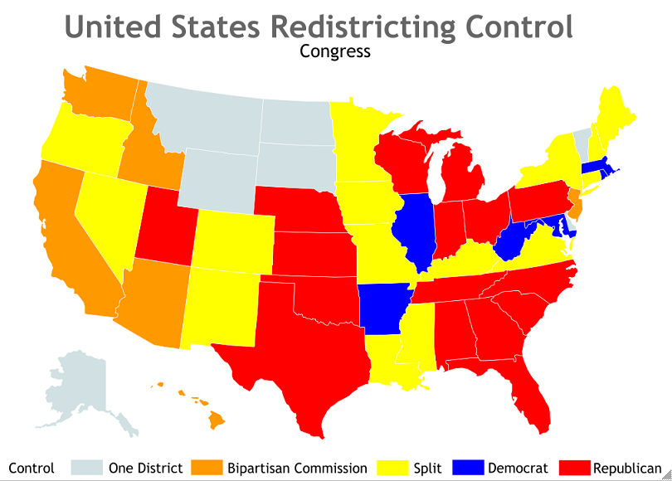R
Public Mapping Project, http://www.publicmapping.org/redistricting-forecast
Red States: Republicans control the state legislature and executive branch.
Blue States- Democrats control the state legislature and executive branch.
Yellow States- One party controls the legislature and the other controls the executive branch.
Orange- States that use a bi-partisan commission to draw districts
Light Blue- States with only one district
Think abouts:
Look up the 2010 mid-term results and compare them with this map.
To what extent do you think that gerrymandering played a part in the 2010 elections? Why?
What results might you have expected to see in Orange states? What were the results? Does that say anything about the effect of gerrymandering?

The Case of the Curious Gerrymander
Clue #4: How to Use Re-districting to One’s Advantage
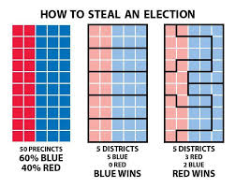

'Packing' and 'cracking'
Throughout U.S. history, Democrats and Republicans alike have been accused of drawing political districts in ways that favored their own interests.
It typically occurs in one of two ways:
—“Packing” a large number of voters from the opposing party into a few districts to concentrate their votes.
—“Cracking,” in which the majority party spreads the opposing party’s supporters among multiple districts to dilute their influence.
Another way of explaining it: When the party controlling the redistricting process sets out to draw lines, it has detailed information about the number of supporters the opposing party has, and where they reside. It sets out to shape districts so its opponents’ votes are wasted — spreading them out in some places so they are unlikely to win, and compacting them in others so they have far more votes than they need for victory. This strategy is often used to limit the power of minority voters. Both methods allow the party already in power to translate its votes into a greater share of victories — or, put another way, to be more efficient with its votes.
http://www.businessinsider.com/partisan-gerrymandering-has-benefited-republicans-more-than-democrats-2017-6
The Case of the Curious Gerrymander
Clue #5: Gerryrigged
Watch the documentary: GerryRIGGED: Turning Democracy on its Head produced by the non-profit organization One Virginia 2021.(Virginia centric)
Documentary: https://www.youtube.com/watch?v=vD3ZZ-wzrHQ
Or for a more national focus:

National Law Journal: 2017 EMMY NOMINEE: Gerryrigged! Is Re-districting Killing Our Democracy?
Documentary: https://www.youtube.com/watch?v=mOL5YMzfdxc

The Case of the Curious Gerrymander
Clue #6

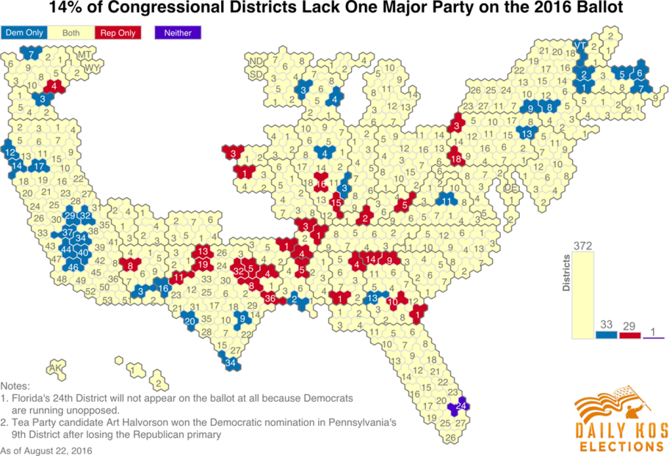

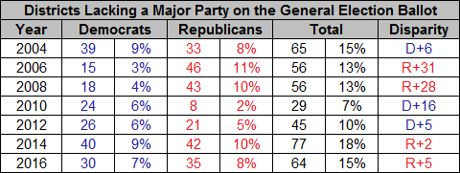
www.dailykos.com
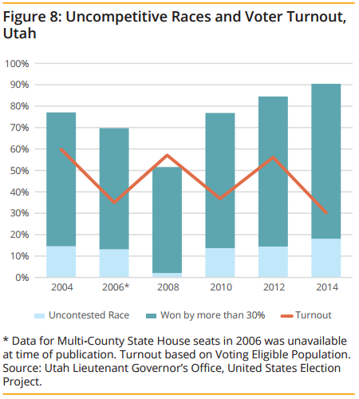

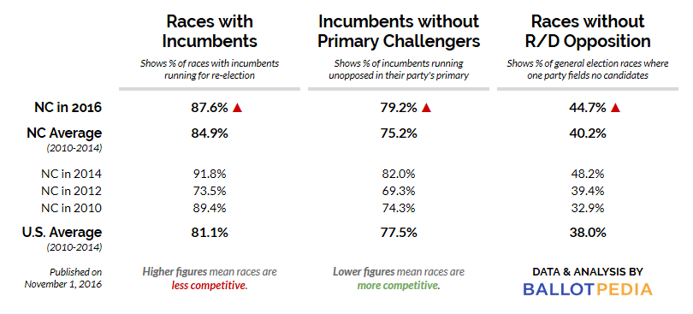

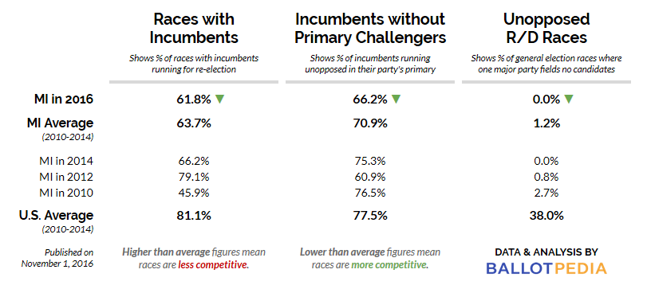

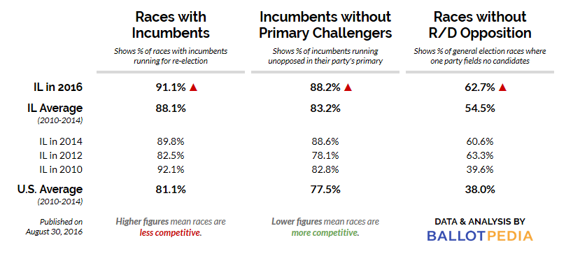

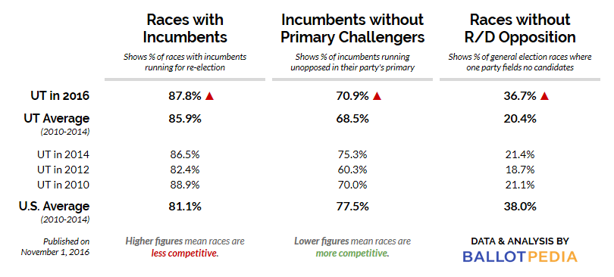

Clue #6: Background Data on Re-districting
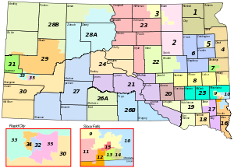 https://en.wikipedia.org/wiki/South_Dakota_House_of_Representatives

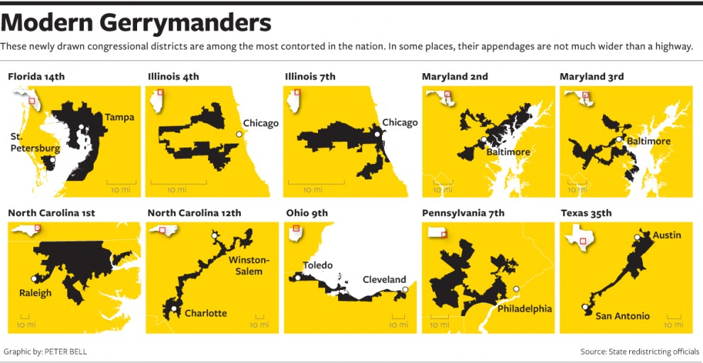
http://redistricting.lls.edu/who.php
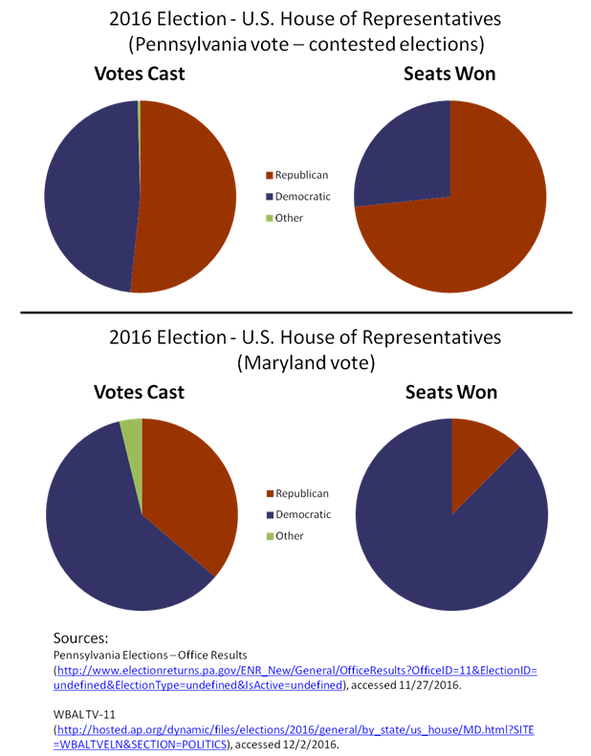

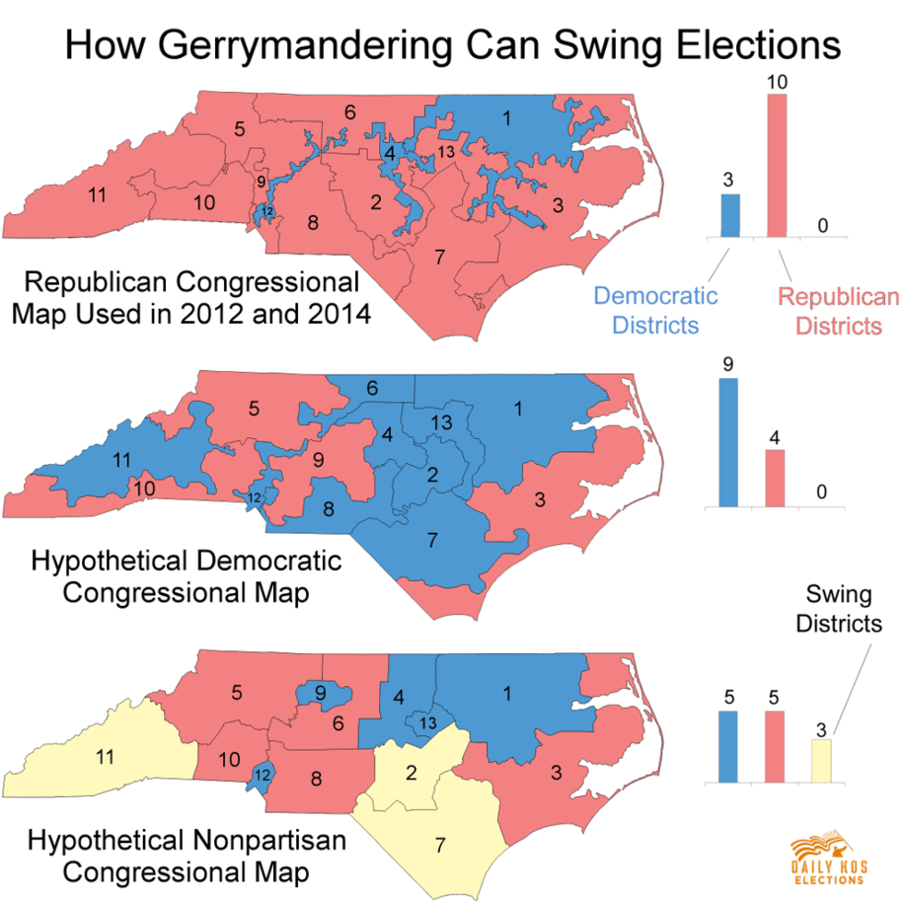

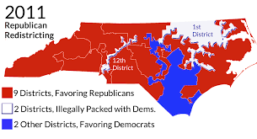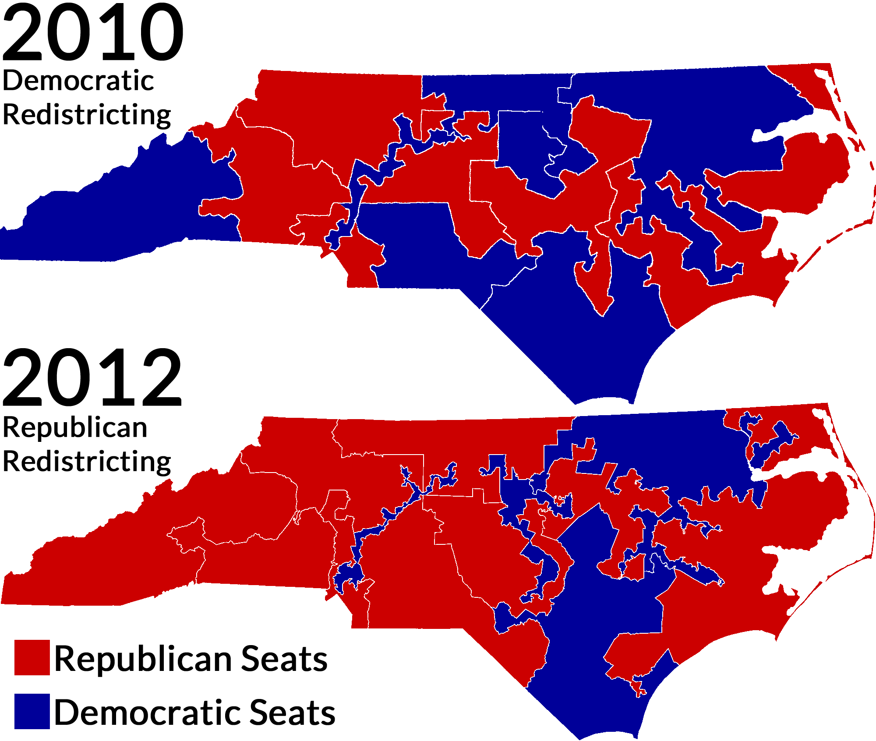
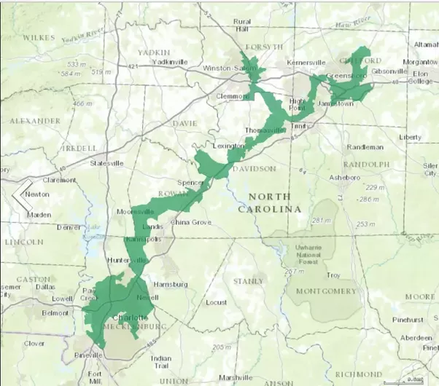

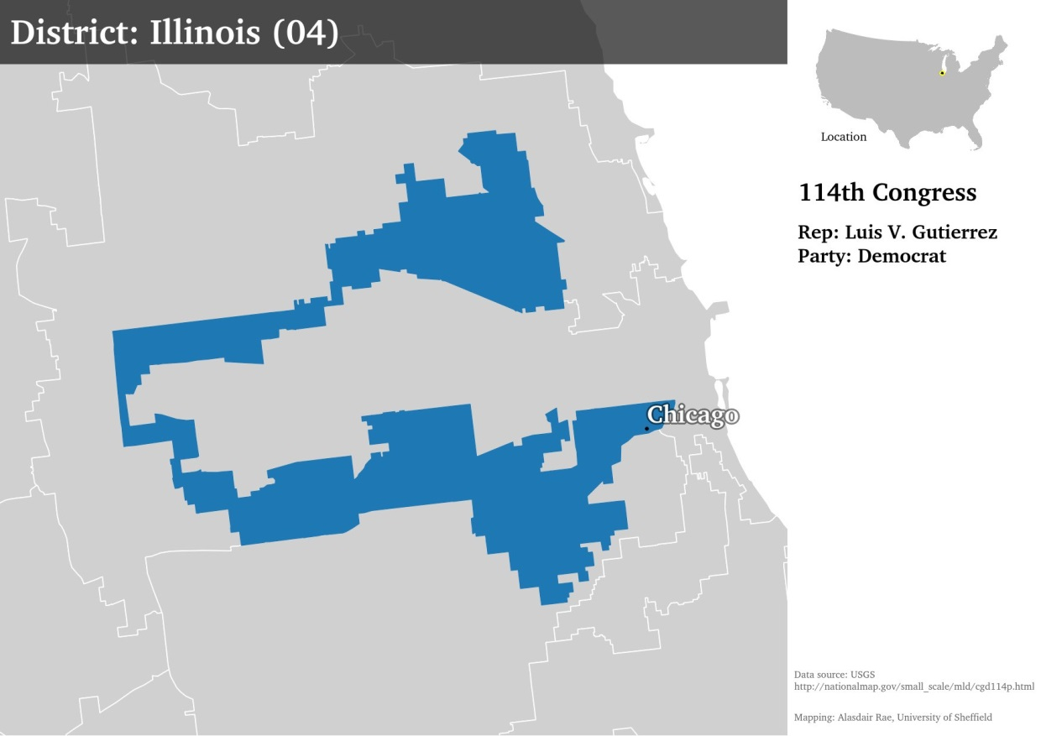

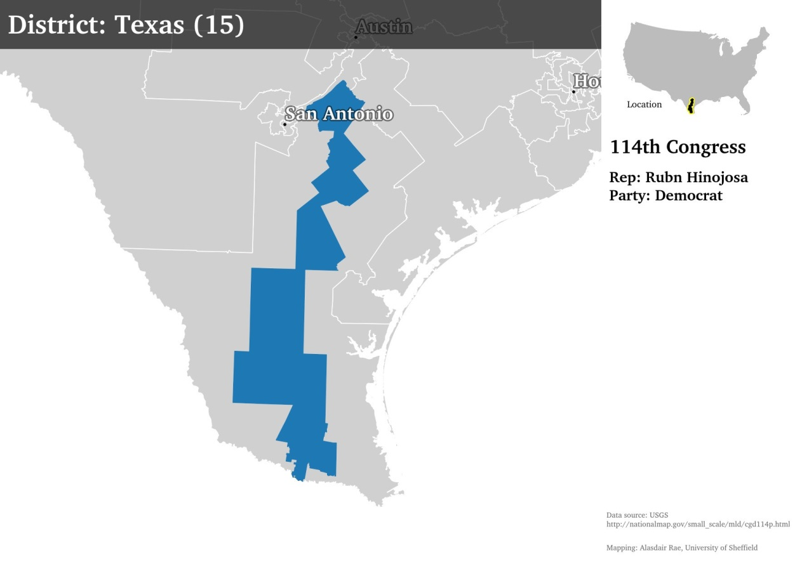
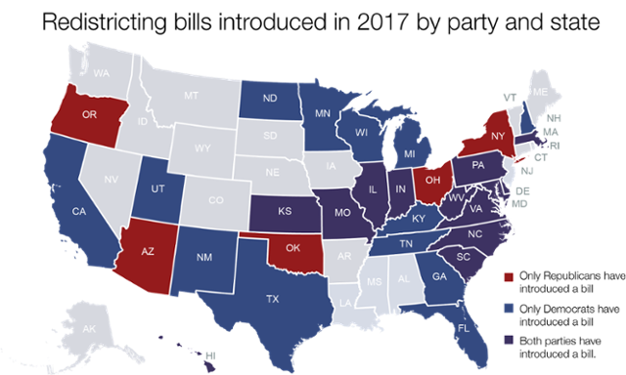

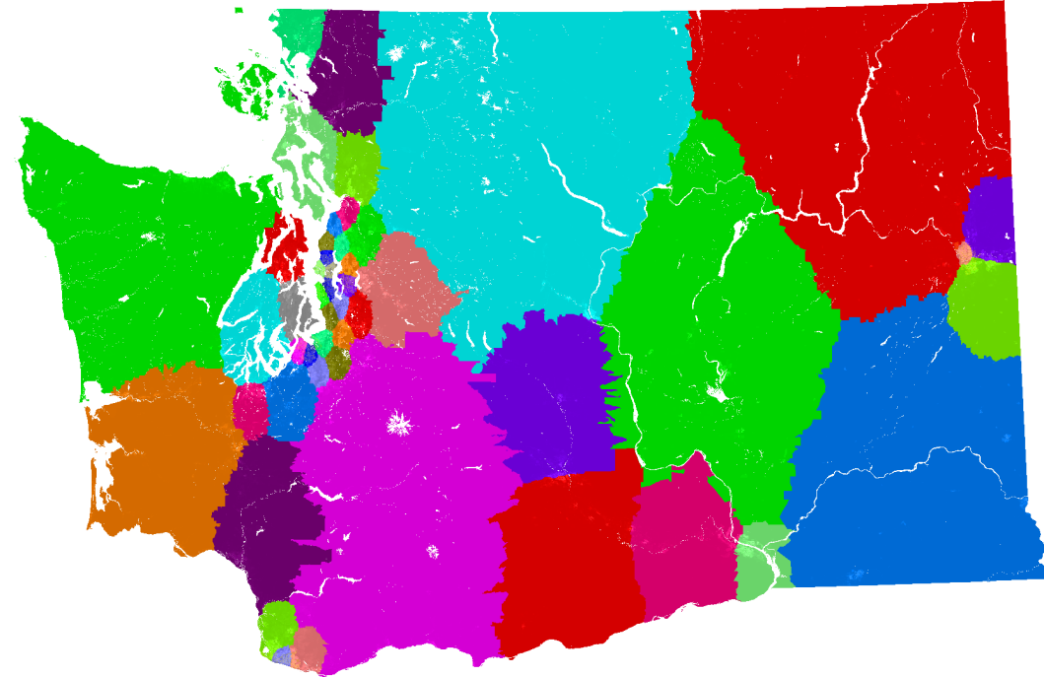
Washington State, Congressional District Map
http://hdcadvance.blogspot.com/2012/01/who-represents-you.html

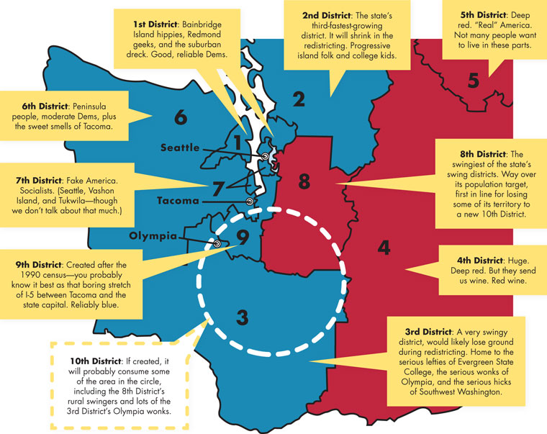
http://www.championshipsubdivision.com/forums/viewtopic.php?t=45050&start=50

The Case of the Curious Gerrymander
Redistricting Resource Guide
The following organizations and websites provide information on Gerrymandering throughout the United States. Visit their websites to find evidence to support your case on redistricting.

FairVote
6930 Carroll Avenue, Suite 610
Takoma Park, Maryland 20912
(301) 270-4616
fairvote.org

League of Women Voters
1730 M Street NW, Suite 1000
Washington DC 20036-4508
(202) 429-1965
lwv.org

Public Mapping Project (Website)
223 Anderson Hall
P.O. Box 117325
Gainesville, FL 32611
publicmapping.org

The United States Elections Project (Website)
223 Anderson Hall
P.O. Box 117325
Gainesville, FL 32611
electproject.org

Virginia Specific:
OneVirginia2021
INFO@OneVirginia2021.org
P.O. Box 1054
Richmond, VA 23218
804-240-9933
www.onevirginia2021.org

All About Redistricting (Website)
Loyola Law School
919 Albany St. Los Angeles CA
(213) 736-1000
redistricting.lls.edu

Brennan Center for Justice
New York University
161 Avenue of the Americas, 12th floor
New York, New York 10013
(626) 292-8310
brennancenter.org

Campaign Legal Center
1411 K St. NW, Suite 1400
Washington, DC 20005
(202) 736-2200
campaignlegalcenter.org

Common Cause
1133 19th Street NW, 9th Floor
Washington, DC 20036
(202) 833-1200
commoncause.org

Cook Political Report (Online Publication)
The Watergate
600 New Hampshire Ave. NW
Washington, DC 20037
(202) 739-8525
cookpolitical.com

